StudyBot : AI-Powered Study Assistant

1. Project Overview
StudyBot is an AI-powered study assistant built using FastAPI and a Large Language Model.
The application allows students to ask study-related questions and receive clear, contextual explanations.
It uses MongoDB to store chat history, enabling the bot to remember previous conversations and provide context-aware responses.
The project demonstrates how real-world AI assistants maintain memory and persist user data

2. Tech Stack
Backend: Python, FastAPI
AI Model: Groq LLM (via LangChain)
Database: MongoDB Atlas
Deployment: Render
API Server: Uvicorn

3. System Architecture
The user sends a request to the FastAPI /chat endpoint. The backend retrieves previous chat messages for the same user from MongoDB. These messages are combined with a system prompt and the new question. The combined context is sent to the LLM, which generates a response. The response is returned to the user and stored in the database for future context.

4. Memory Implementation
The chatbot uses MongoDB to store user-specific chat history. Each message is stored with a user-id, question, answer, and timestamp. When a new question is asked, the system retrieves previous messages for that user only, ensuring conversation isolation. This allows the chatbot to provide context-aware responses while preventing data leakage between users

5. API Endpoint
The API endpoint is POST /chat

For example:
Request body:
{
"user_id": "student_1",
"question": "Explain Newton's First Law"
}

Response:
{
"answer": "Newton's First Law states that..."
}

6. Deployment Details
The application is deployed on Render as a web service. Environment variables such as the Groq API key and MongoDB URI are securely configured on the Render dashboard. The deployed API is publicly accessible and can be tested using the FastAPI Swagger interface.

7. Live Project Links
- GitHub Repository:
https://github.com/anushatambi/studybot-fastapi
- Hosted API Link:
https://studybot-fastapi.onrender.com
- Swagger Docs:
https://studybot-fastapi.onrender.com/docs

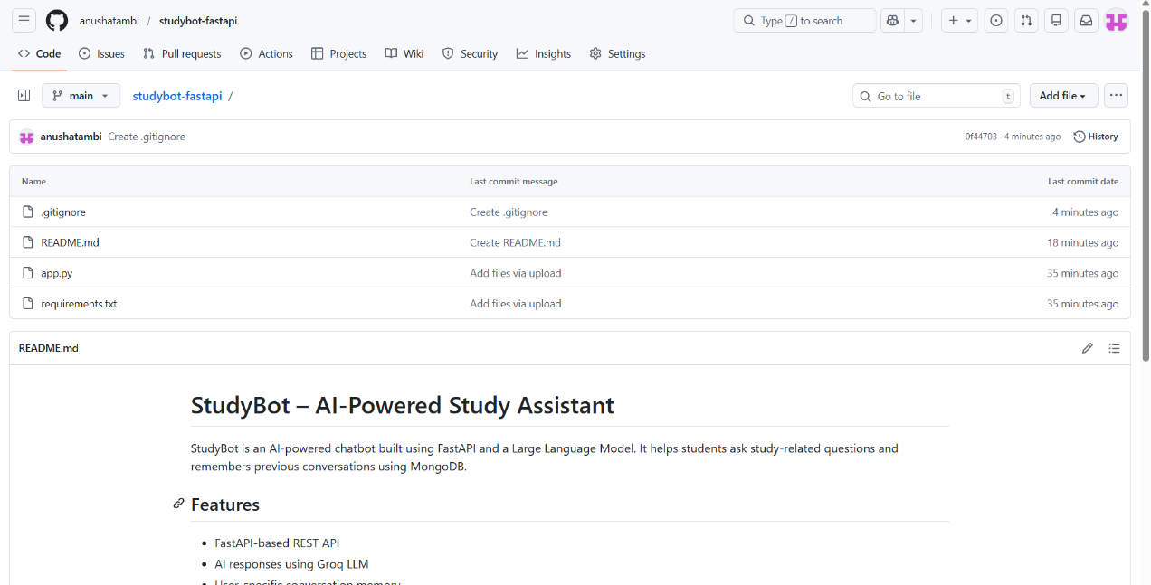
8. Screenshots

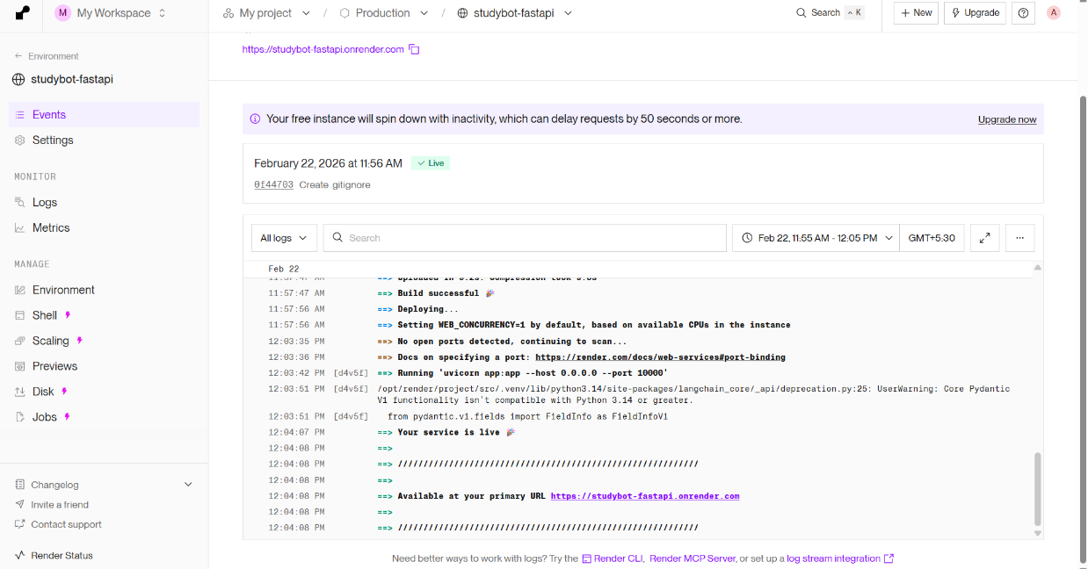
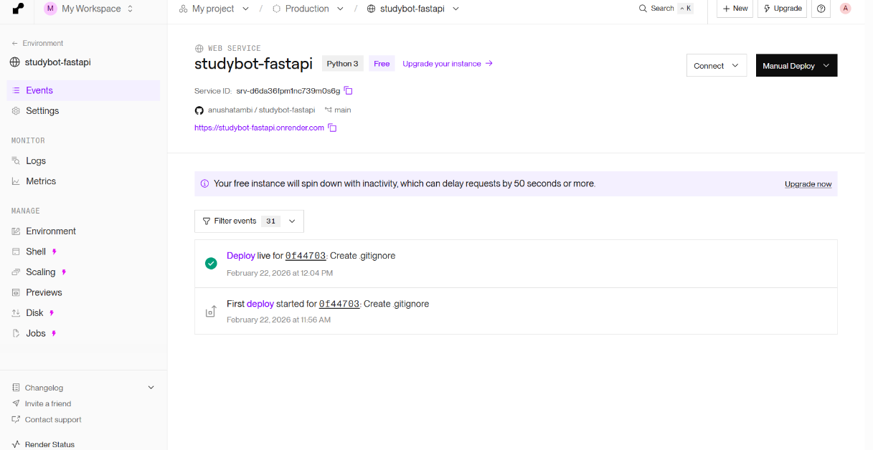

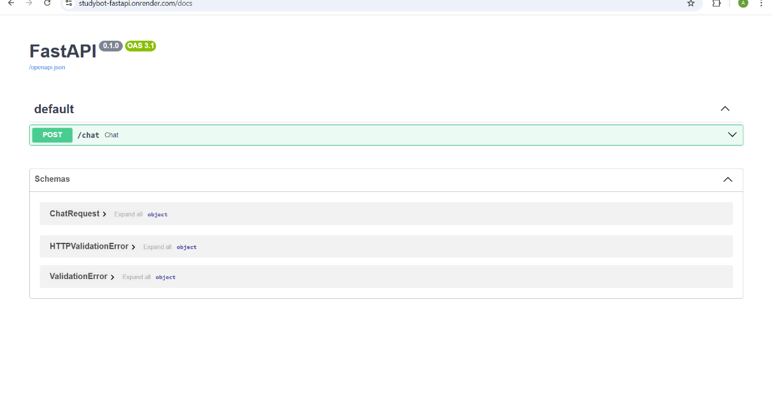

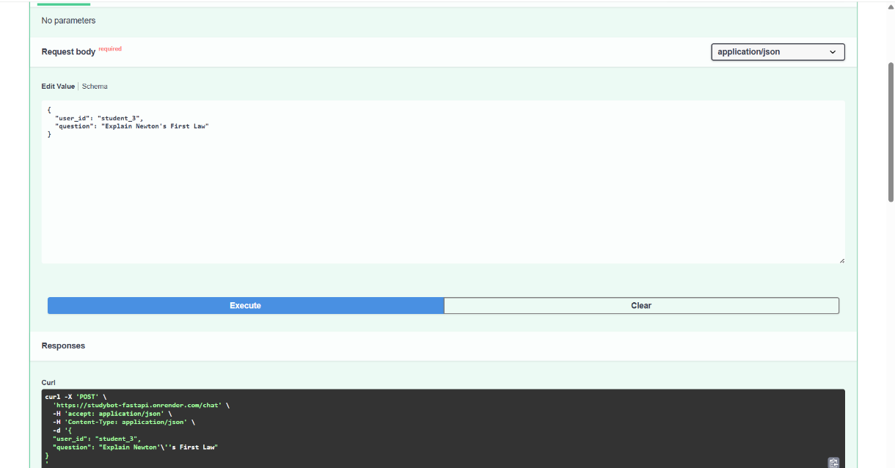

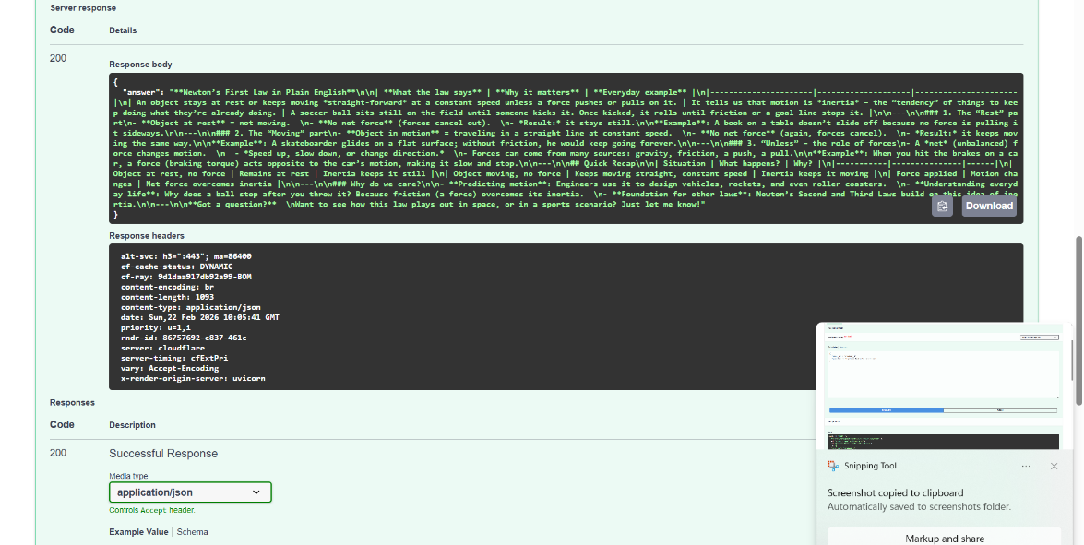

9. Conclusion
This project successfully demonstrates the implementation of an AI-powered study assistant with persistent memory. By combining FastAPI, MongoDB, and an LLM, the application mimics real-world AI assistants that maintain conversational context. The project provided hands-on experience with backend development, AI integration, database design, and cloud deployment.

